**Design Opportunity**

Through research and interviews, our team found that medical institutions did not use shared information about patients’ previous health conditions and problems. This situation may cause doctors to not fully understand the patient’s medical history and lead to misdiagnosis. In domain research, we found some potential design opportunities and initial concepts. When consulting a doctor, patients may encounter problems that it is difficult for them to describe their symptoms. For doctors, they need to know all the information accurately [1]. Through research, our team believes that we need to use mobile application technology to help patients collect their health information and share this information with the patient's attending physician. In another paper, a patient-centred application for recording health records was proposed. Doctors can directly view the patient's medical records, which can prevent patients from missing important information when communicating with doctors [2]. Furthermore, it is mentioned in the paper that in the field of medical care and related fields, new technologies can be applied to monitor the state of the body, that is, blood sugar level, eye condition, heart rate, etc. Cloud storage and real-time data exchange technologies allow people to monitor their physical health anytime and anywhere, and doctors can also check their health without time and distance restrictions, so as to intervene in avoidable major diseases as soon as possible [3].

Based on the results of our team’s interviews and research, our team believes that we can design an application for patients to store patient medical and health records. Users can choose to share their medical records and health data with their doctors, so that doctors can better treat patients by obtaining complete records of patients. The basic principle of the application is that users hold their own health data through mobile phone storage, and users can view their own health data anytime and anywhere. When the user goes to the doctor, she can choose to share her medical history with the doctor, and the doctor will obtain the patient's health data. After the doctor's diagnosis is completed, the doctor can input the diagnosis result and treatment plan into the application so that the patient can view or share the data with other doctors in time. At the same time, when the doctor obtains the user's authority, he can monitor the user's health data in real-time for timely intervention and treatment.

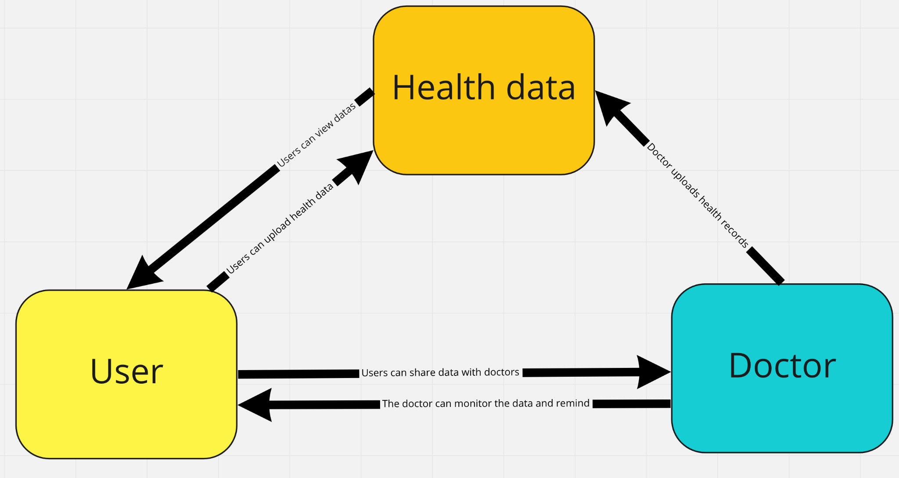

*Figure 1: Fundamental*

In the design of the application, we will consider how to align our conceptual model with the user's mental model. The paper mentions that the patient’s cognition is taken as the main consideration, through visualized visual symbols, pictures and videos to help patients understand the concept of health and the state of health [4]. The application of our group will express the health status of patients through visual symbols in different colors. Red usually represents danger and green represents health. In addition, after the doctor enters the diagnosis information, the application will provide pictures or videos to help users understand complex disease concepts.

**References**

[1] Courtney Crooks, Rachel Feinberg, Talia Ayala-Feliciangeli, Kunal Dhodapkar, Sonam Singh, and Rosa Arriaga. 2020. Design and Evaluation of Mobile Mental Health Resources for First Responders. In Proceedings of the 14th EAI International Conference on Pervasive Computing Technologies for Healthcare (PervasiveHealth '20). Association for Computing Machinery, New York, NY, USA, 396–399. DOI: <https://doiorg.ezproxy.library.uq.edu.au/10.1145/3421937.3421968>

[2] Sadaf Khurram and Khurram Sardar. 2020. Patient-Centric Mobile App Solution. In Proceedings of the Australasian Computer Science Week Multiconference (ACSW '20). Association for Computing Machinery, New York, NY, USA, Article 42, 1–4. DOI: <https://doi.org/10.1145/3373017.3373063>

[3] Jan Derboven, Roos Voorend, Gennaro Tartarisco, Flavia Marino, Giovanni Pioggia, Sebastiano Nucera, and Katleen Van der Gucht. 2018. Mhealth and psycho-physical well-being. In Proceedings of the 10th Nordic Conference on Human-Computer Interaction (NordiCHI '18). Association for Computing Machinery, New York, NY, USA, 952–955. DOI: <https://doi.org/10.1145/3240167.3240261>

[4] Yair G. Rajwan and George R. Kim. 2010. Medical information visualization conceptual model for patient-physician health communication. In Proceedings of the 1st ACM International Health Informatics Symposium (IHI '10). Association for Computing Machinery, New York, NY, USA, 512–516. DOI: <https://doi-org.ezproxy.library.uq.edu.au/10.1145/1882992.1883074>